Civilizing Injustice? Colonial Conquest and Moral Pretexts
Executive Summary: This report critically examines the claim that foreign powers may legitimately conquer or annex a society because it tolerates grave injustices. In three historical case studies (British India’s abolition of sati, French Algeria’s “civilizing mission,” and U.S. rule in the Philippines via “benevolent assimilation”), we compare the stated moral pretexts to the actual motives, processes, and outcomes of conquest. We show that colonial powers often used humanitarian rhetoric as a pretext for expansion, not as an honest driver of policy. These examples, together with the international legal framework (UN Charter, self-determination, customary international law) and modern norms (humanitarian intervention, Responsibility to Protect), demonstrate that conquest under the guise of stopping injustice is not legally or ethically justified. We analyze the consequences of this doctrine: collective punishment of entire societies, loss of agency and self-determination for colonized peoples, the hypocrisy of imperial powers, and perverse incentives to seek moral pretexts for aggression. We conclude that the only legitimate route to end atrocities is internal reform or authorized collective action, and we make policy recommendations to strengthen international norms against conquest and to address abuses through lawful and cooperative means.

Thesis and Methodology
Thesis: I argue that the notion of a “moral” license to conquer or annex because a society tolerates injustice is fundamentally flawed. History shows that colonial powers’ humanitarian rhetoric obscured underlying economic and strategic motives, inflicted collective punishment, and violated the rights of entire peoples. Modern international law (UN Charter, customary law) forbids such conquest regardless of pretext. Allowing a “civilizing” or “benevolent” rationale would undermine sovereignty, self-determination, and the rule of law.
Methodology: I conducted a thorough review of primary sources (e.g. colonial proclamations, UN Charter, security council resolutions) and reputable historical analyses. I relied on official documents (Britannica entries, historical archives, United Nations texts), academic scholarship (e.g. legal commentaries on use of force and decolonization), and key primary accounts (McKinley’s benevolent assimilation order[1][2], UN resolutions). I gathered evidence on each case study by examining both the colonial narratives and the indigenous responses. International legal sources (UN Charter Article 2(4)[3], the 1970 UN Declaration on Friendly Relations[4][5], etc.) were reviewed to frame the legal prohibition on conquest. I also surveyed literature on humanitarian intervention and R2P to consider counterarguments. The research was limited to English-language sources and official/unofficial documents accessible online; some colonial-era perspectives and non-English scholarship may be underrepresented.

Historical Background: Empire and the “Civilizing” Myth
From the early modern era through the 20th century, European empires often justified conquest in moral terms. For example, the British Empire cited the need to suppress sati (widow immolation) in India, while French imperialists invoked a mission civilisatrice (civilizing mission) to “uplift” North African and Southeast Asian peoples. The United States, emerging as a colonial power in the late 19th century, spoke of “benevolent assimilation” to rationalize taking the Philippines. In each instance, colonizers claimed humanitarian or progressive intentions.
However, the actual motives for empire were usually economic, strategic, or prestige-related. The East India Company – “an English trading company” formed in 1600 – turned into “an agent of British imperialism in India”, gradually seizing territory for profit and power[6]. Similarly, Algeria’s conquest began in 1830 under a French king eager for prestige and agricultural land, not primarily to save Algerians from tyranny[7][8]. Likewise, the US invasion of the Philippines in 1898 was driven by geopolitical rivalry and commercial interests, even as leaders claimed a civilizing purpose[2].
These examples suggest that moral rhetoric often serves as a pretext for conquest. I will examine each case in detail to show how the rhetoric matched (or masked) reality.

Case Study 1: British India and Sati
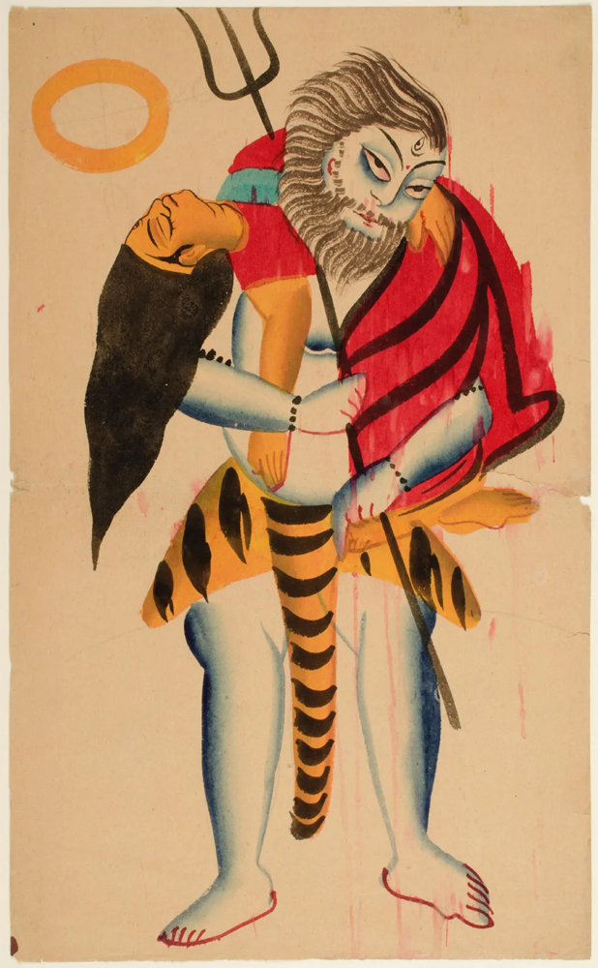
Figure: Horace Vernet, Shiva Carrying the Dead Sati (1840s). In Hindu mythology, Sati (the goddess) self-immolates on her father’s funeral pyre. Colonial depictions of such myths fueled British outrage over widow-burning (sati) practices in India[9].
In early 19th-century India, sati (also spelled suttee) was a social custom in which a widow immolated herself on her husband’s funeral pyre. It was never a universal practice across all of India; in fact, sati was mostly confined to certain upper castes (e.g. Brahmins and royalty) and regions. Britannica notes that “sati was considered to embody the ideal of womanly devotion held by certain Brahmin and royal castes”, implying it was not practiced by ordinary people[10].
British colonial authorities initially tolerated sati to avoid upsetting local elites. Governor-General Warren Hastings (in power 1772–1785) famously said he would abolish sati “if he could have relied upon the popular feeling being in his favour… [but] the danger was felt… only in England”[11]. Nevertheless, the outrage at sati in Britain grew. By the 1820s, Indian reformers like Raja Ram Mohan Roy (1772–1833) spearheaded campaigns against sati. Roy’s work (backed by Western-educated elites) invoked both humanitarian and scriptural arguments to end the practice. In December 1829, following investigations and debates, Governor-General Lord William Bentinck officially outlawed sati in Bengal and other regions under company rule[12][13]. Britannica confirms “sati was outlawed in 1829 during British colonial rule”[13].
Thus, in India the outcome was the abolition of sati (which indeed ended the practice under British jurisdiction). However, this achievement was a joint one: it reflected indigenous reform movements and colonial authority. Notably, sati was being eradicated largely by Indians themselves; the British role was to formalize and enforce a ban. Crucially, the British did not conquer India in 1829 because of sati; they had already expanded greatly through wars (e.g. Plassey 1757, Delhi 1803) for commercial power. The sati prohibition came after much conquest, not as its cause.
Moreover, the moral argument against sati should not retroactively justify British conquest of India. The East India Company’s rule was driven by trade and revenue, not by a mandate to end religious practices. As Britannica explains, the Company “became involved in politics and acted as an agent of British imperialism in India” throughout the 18th and 19th centuries[6]. Even after sati was banned, British rule remained exploitative: heavy taxation (the 1818 Permanent Settlement) and revenue demands (Hastings admiring “the revenue it brings in”[14]) often worsened the lot of ordinary Indians. The company and later the Crown did little to alleviate poverty or other social ills; in fact, colonial policies exacerbated famines and unrest (the 1857 revolt, for example).
In short, the existence of sati did not confer any moral license to conquer India. The British conquest was an act of imperial expansion, not humanitarian intervention. As Tocqueville observed in a different context, colonialism tended to “destroy” societies rather than “civilize” them[7]. While banning sati was laudable, it does not retroactively justify empire. Conquering “to protect people from sati” would punish millions of Indians who never practiced it. It would impose foreign rule on those who had no say in ending the practice. In effect, it would collectively punish the whole society for the crimes of a few families or priests.

Case Study 2: French Algeria and the Civilizing Mission
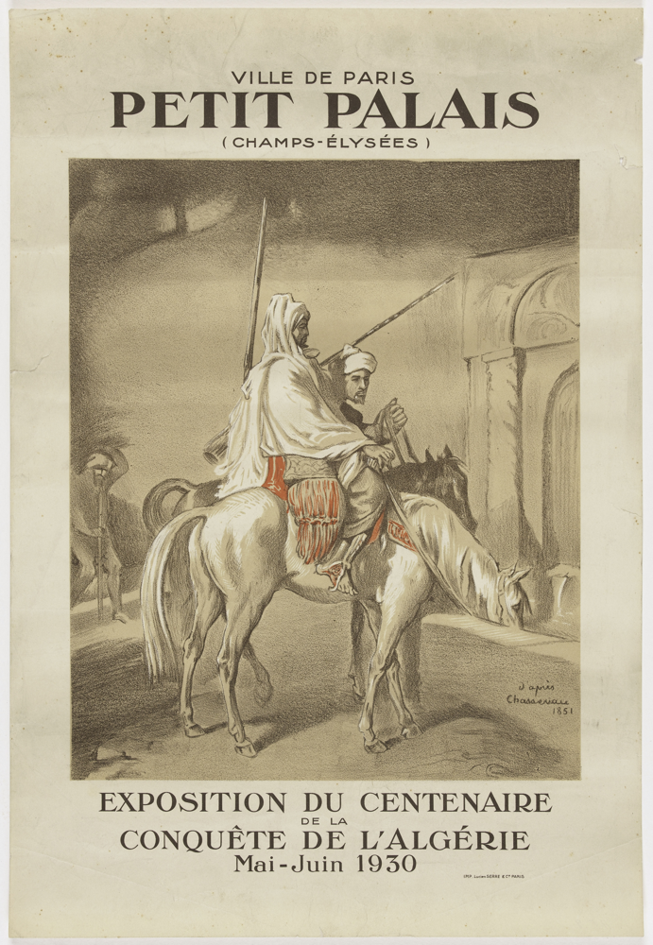
Figure: French poster (1930) celebrating “Le Centenaire de la conquête de l’Algérie (1830–1930).” Official propaganda depicted Algeria’s colonization as a heroic triumph. In reality, French rule in Algeria was a brutal settler-colonial project, not a benign civilizing effort[7][8].
France invaded Algeria in 1830, ostensibly to punish piracy and stabilize the region. From the start, French rhetoric framed it as bringing civilization to Muslims. The Third Republic’s politicians (e.g. Jules Ferry) later justified empire with phrases like “supérieur races have the right over inferior races; they have the duty to civilize them.”[15] Such views were common: many French believed Algeria needed French schools, religion, and laws to become “modern.”
Territorial Annexation: In practice, France seized and colonized Algeria rapidly. After military conquest of key cities (Algiers, Constantine etc.), by 1848 the settler population (the colons or pieds-noirs) pushed the government to incorporate Algeria as part of France. In 1848, France made the former Ottoman provinces into full French departments and offered French citizenship to European settlers[8]. That action meant Algeria was legally French territory – not a protectorate – with representation in the French parliament. However, indigenous Muslims were excluded. They remained under Muslim law (administratively subject to the “Arab Bureaux” under military governors) and could only become French citizens by renouncing Islam (a virtually nullifying condition). Thus colonial policy created a two-tiered system: settlers had full rights; the vast majority (Muslims) had none.
Violence and Resistance: French colonial rule was marked by extreme violence. Historian Abdel Kader Chanderli summarizes that from 1830–1847, France ruled by a “tradition of violence and mutual incomprehension”[7]. For example, after crushing resistance in Kabylia in 1871 (an Algerian Muslim uprising), France confiscated huge tracts of tribal land to settle European refugees[16]. Millions of Algerians died in the 19th century from warfare, disease, and famine; reliable estimates show the population fell by nearly one-third between 1830 and 1870 due to the invasion[17].
Despite the civilizing rhetoric, French rule effectively uprooted traditional society. As Chanderli notes, Tocqueville commented that colonization “made Muslim society more barbaric” than before[7]. The reason is clear: dispossession, war, and segregation disrupted communities. The poster in Figure 2 glamorizes colonialism, but the reality was a settlers’ regime. By 1862 the majority of cultivable land belonged to Europeans, and famine was common among displaced peasants[18].
Outcome: Over 130 years (1830–1962), France never fully achieved its moral aim of “civilizing” Algeria. Instead, they faced prolonged insurgency (especially during the Algerian War of Independence, 1954–62). In 1962 Algeria achieved independence at a tremendous human cost (hundreds of thousands dead). The French “civilizing mission” ended in collapse and mutual bitterness. Notably, when nationalism and claims of injustice (denial of rights, repression) prompted revolution, France (and the world) recognized the Algerians’ right to self-determination.
If one had accepted from the outset that France could legitimately take over all Algeria to end abuses, it would violate the same principle it purported to defend. Collective punishment of all Algerians for the practices of a few (or the existence of Sharia law, for example) is ethically wrong. Moreover, many Algerians were pleased by the idea of reforming their society (some even supported secular education), but they resented foreign conquest and domination. The Islamic and social institutions themselves could be changed by Algerians (indeed they changed after independence) without requiring foreign takeover. French colonialism in Algeria shows that using the “civilizing” pretext to justify seizing territory can lead to injustice on a massive scale.

Case Study 3: U.S. Philippines and “Benevolent Assimilation”
In 1898, the U.S. defeated Spain in the Spanish-American War and acquired the Philippines by the Treaty of Paris. President William McKinley proclaimed the goal of “benevolent assimilation”: Americans were to govern the Filipinos not as conquerors, but “as friends, to protect the natives… in their personal and religious rights,” working “for the greatest good of the governed”[1][2]. He promised to substitute “the mild sway of justice and right for arbitrary rule,” invoking high-minded intentions[2].
McKinley’s proclamation (an Executive Order to military commanders) encapsulated the moral pretext: Filipinos were allegedly incapable of self-rule and needed American tutelage. However, the reality differed sharply. The Philippine revolutionary government (the Malolos Republic) had declared independence from Spain in June 1898, months before the US–Spain peace treaty. Filipinos initially welcomed the US as fellow Christian republicans, but relations quickly soured when the U.S. imposed martial law. President McKinley’s own investigatory commission (the Schurman Commission, 1899) found Filipinos overwhelmingly wanted independence[19]. Nevertheless, the U.S. simply refused to recognize the Philippine Republic.
Military Conquest: The Philippines was thus conquered by force. The Philippine–American War (1899–1902) ensued, costing roughly 4,000 American and tens of thousands of Filipino combatants, along with perhaps 200,000 civilian lives (many from disease)[1][19]. Many accounts describe harsh tactics (reconcentrados, harsh suppression of guerrillas) comparable to colonial conquests elsewhere. Only after several years of violence did the U.S. establish an American-style civil government. Even so, it was not genuine partnership; Americans retained ultimate control of the military, key appointments, and fiscal policy[20].
Outcome: The U.S. did eventually legislate a promise of independence (the 1916 Jones Act), and the Philippines became a Commonwealth after 1935, gaining full independence in 1946. While American rule did build schools and infrastructure (increasing literacy dramatically by the 1930s[21]), it also entrenched inequities. Land and political power remained concentrated among local elites who collaborated with Americans[22]. Whether or not the U.S. had the intention to “elevate” Filipino society, the result was a long colonization that delayed Filipino self-government.
Moral Pretext vs Reality: The benevolent assimilation rhetoric is exposed as a cover for imperialism. Filipinos never consented to ceding sovereignty; they saw Americans as invaders and fought. Citing moral duty to “civilize” a people who overwhelmingly desired independence ignores their agency and right to choose their own institutions. Indeed, as the Philippine Commission recognized in 1899, Filipinos “wanted ultimate independence”[19]. Conquest forcibly denied that right.
If we had accepted the claim that U.S. conquest was legitimate because some Philippine practices were backward (for example, remnants of feudal landholding or a revolution that involved violence), it would still be wrong. First, many such issues could have been addressed by Filipino reformers after independence. Second, it treats the entire Filipino population as subjects of punishment for the policies of their government or tradition. Third, it contradicts the U.S. own professed ideals of freedom and consent of the governed. In practice, U.S. actions in the Philippines are now widely regarded as unjust colonialism, not as benevolent intervention.

Comparative Table of Cases
Case | Dates | Interveners | Stated Moral Pretext | Outcome | Long-term Effects
British India (sati) | 1757–1947 (Company/Raj) | Britain (EIC/Crown) | Suppress sati; civilize Hindus[9][13] | Sati outlawed 1829[13]; Company/Raj consolidation; eventual independence (1947) | Social reform in India achieved mostly by Indians; imperial exploitation and famines under British rule. Imperial rule ended as self-determination gained global acceptance.
French Algeria | 1830–1962 | France (3rd Rep., etc.) | “Civilizing mission” to uplift Muslims; impose French republican values | Violent conquest; annexed as French departments by 1848[8]; long military rule; independence war (1954–62) | Deep trauma; major population loss; eventual independence (1962) after a brutal war. Legacy of mistrust; decades of emigration of colons.
U.S. Philippines | 1898–1946 | United States | “Benevolent assimilation” to prepare Filipinos for self-government[1][2] | Spanish rule replaced by American military conquest (Philippine–American War, 1899–1902); U.S. colonial administration to 1946 | Raised literacy/health but also economic inequality. Independence (1946) achieved after WWII. U.S.–Philippines ties remain (security, culture). Debate on colonial legacy endures.
Table: Each case demonstrates a “moral” pretext (right column) that cloaks strategic goals. For instance, Britain used sati as a humanitarian cause even as it fought wars to expand its empire; France touted civilization while seizing land; the U.S. claimed altruism while establishing a colonial regime. The outcomes show that military conquest and foreign rule were the real processes.

Legal Framework: Sovereignty and Prohibitions on Annexation
Modern international law plainly rejects conquest. The UN Charter (1945) embodies the post–World War II consensus against forceful annexation. Article 2(4) states that all UN members must “refrain in their international relations from the threat or use of force against the territorial integrity or political independence of any state”[3]. This encompasses annexation by force. In other words, even if a state claims moral reasons, it has no legal right to invade or annex another state. The UN system replaced the era of “might makes right” with collective security and sovereign equality.
Additionally, UN resolutions have codified related principles. The 1970 Declaration on Principles of International Law (GA Res. 2625) reiterates sovereign equality and self-determination: it reaffirms “the principle of equal rights and self-determination of peoples… [including] the right of all peoples freely to determine… their political status”[4]. It also confirms that no UN Charter provision allows seizing territory by force. The International Court of Justice has recognized these norms as customary law (e.g. Nicaragua v. USA 1986 cited Res. 2625). In short, after 1945 the idea that states have a right to conquer “backwards” societies has no standing in international law.
Even beyond the UN, classical laws of war and diplomacy (e.g. 1907 Hague Regulations) barred conquest. Colonial-era justifications stood on shaky ground: as modern scholars note, the doctrine of conquest and annexation has been “regulated out of international law”[23]. Post-war agreements (like the U.N. Charter, Geneva Conventions, and the 1974 Definition of Aggression) leave no loophole for annexing territory on moral grounds.
Therefore, the claim that “we can annex because they did bad things” conflicts with jus cogens law (peremptory norms). Any such annexation would be illegal and likely invalidated by the UN Security Council or International Court. Our case studies are all pre-1945, but they illustrate why those later rules emerged: they were a reaction against just this kind of imperial logic.

Counterarguments: Humanitarian Intervention and R2P
One might counter: what if grave abuses (genocide, mass atrocities, ethnic cleansing) occur? Doesn’t the international community have a duty to intervene, even militarily? This is the modern rationale of humanitarian intervention and the Responsibility to Protect (R2P).
The R2P doctrine (endorsed by the UN in 2005) holds that when a state “is manifestly failing” to protect its population from genocide, war crimes, ethnic cleansing, or crimes against humanity, the international community has an obligation to act[24]. However, R2P is not a carte blanche for regime change or annexation. It envisages limited collective action (diplomacy, sanctions, or UN-authorized force) to protect people, not to conquer territory. Even R2P’s architects stressed that such intervention must be multilateral and proportionate. The ICISS report and UN documents specifically distinguish R2P from imperial conquest or collective punishment[24].
Crucially, Western insistence on acting against crises (e.g. Kosovo 1999, Libya 2011) has been very selective. NATO’s bombing of Yugoslavia in 1999 was justified by many as a “moral imperative” to halt ethnic cleansing[25], but it lacked UN approval and the peace settlement left Kosovo still in tension. In Libya (2011), UN mandates to protect civilians produced regime change but led to chaos, again showing the limits of unilateral force. The lesson is that even well-intended interventions can fail or be abused; they do not legitimize annexation.
Moreover, “humanitarian intervention” usually addresses immediate crises – not deep-seated cultural practices or political systems. Most human rights violations (even extreme ones) must be solved by empowerment of locals or legitimate international action (e.g. tribunals, UN peacekeeping). The West tends to call for intervention only when strategic interests align; this selective use reveals hypocrisy and undermines the normative claim.
Finally, even R2P respects sovereignty as default. It does not overrule Article 2(4); it only kicks in when a government itself is perpetrating the crimes. The classic scenarios (genocide in Rwanda or Srebrenica) were not solved by annexation but by international justice and pressure. Annexing territory cannot be justified even to stop abuses, because it replaces one set of rulers with another set of rulers – often worse.
In short, while the world rightly rejects “let them die” for atrocity victims, the accepted response is UN-backed, limited intervention and protection – never outright conquest of a country.

Normative Analysis: Agency, Collective Punishment, Hypocrisy, and Perverse Incentives
Collective Punishment and Agency: Conquering a country punishes everyone, not just the guilty. Even if some officials or cultural elites endorse bad practices (e.g. sati, or discriminatory laws), the majority of people may oppose them or are simply bystanders. Imperial conquest strips people of agency; it denies even reformers the chance to change their society themselves. For instance, educated Indians in the early 19th century began petitioning against sati well before British bans. Had Britain invaded the remainder of India for sati, it would have disregarded these Indian voices. Similarly, many Algerian Muslims actually welcomed modern education and reforms, but hated foreign domination. Overlooking such nuances is unjust and arrogant.
Hypocrisy: The moral heavy-lifters of history often had their own injustices at home. Britain’s industrial revolution caused new social ills; France’s colonial system itself practiced torture and mass killing in Algeria[26]; the U.S. subjugated Native Americans while professing to liberate others. When powerful nations claim to act for justice abroad, we must question why they frequently neglected issues at home or in their own territories. The “civilizing mission” is often a cover for imperial arrogance, as Foued Ghedjati observes about French colonial thought[27]. Recognizing this hypocrisy is essential: it shows moral pretexts are double standards if not genuinely universal.
Perverse Incentives: Allowing conquest for moral reasons would encourage opportunism. Nations might manufacture pretexts or exaggerate foreign abuses to justify expansion. As a thought experiment, under this logic any country with political dissidents or human rights abuses could be targeted. For example, would the U.S. have a right to annex allies like Saudi Arabia or Turkey to “liberate” oppressed groups? Clearly not; such a rule would collapse instantly into great-power bullying. International law rightly avoids incentives for war by criminalizing aggression, not by opening loopholes.
Conflict with Self-Determination: Every people have a right to change their own system, including abandoning harmful traditions. The UN principles emphasize that “the choice of methods of reaching [self-determination] is a decision made by the people themselves”[28]. Outsiders have no moral authority to impose their will unilaterally. Genuine reform arises through education, dialogue, and pressure – not through conquest. For example, after independence, India continued to debate social issues internally, while French Algeria’s Muslim community largely sought autonomy rather than integration under a foreign flag.

Conclusion and Policy Recommendations
In conclusion, history and law reject the idea that moral pretexts legitimize conquest. Our case studies show that empires justified aggression by selectively citing social ills, but their interventions often inflicted greater harm. In contrast, modern norms insist on peaceful change.
Key Conclusion: Sovereignty and self-determination are paramount. Even the worst domestic injustices should be addressed first by the society’s own efforts or multilateral means, not by unilateral annexation. The alternative – letting great powers police others’ cultures by force – would create an endless cycle of justified aggression.
Policy Recommendations: - Reaffirm Legal Prohibitions: States and international bodies should clearly reaffirm that Article 2(4) of the UN Charter admits no exceptions for conquest on moral grounds[3]. Any rhetoric suggesting such a right (even rhetorically by leaders or in media) should be unequivocally countered. - Strengthen Internal Reform Aid: Instead of intervening militarily, the international community should invest in supporting internal reformers (civil society, education, legal aid) in countries with injustices. For example, fund NGOs that work to eradicate harmful practices, empower minorities, and uphold rule of law. - Multilateral Crisis Response: In genuine crises (genocide, etc.), act through the UN and regional coalitions, with limited objectives and post-intervention plans, not annexation. The R2P framework can guide this, but must stress sovereignty and responsibility to rebuild, not to take territory[24]. - Account for Hypocrisy: Major powers should practice self-reflection and consistency. Democracies should address their own flaws (racism, inequality, etc.) rather than merely pointing to others. This would build trust and moral authority if intervention is ever contemplated. - Education on History: Finally, teach history critically so that the myth of “benevolent empire” is dispelled. Recognizing the real motives of past interventions will help citizens of all countries demand that today’s leaders not repeat the same mistakes under new guises.
In sum, the world must continue to advocate for human rights and justice, but within the rule-of-law framework of international cooperation. The days of justifying colonialism with moralistic rhetoric must remain in the past.

Timeline (Key Events)
timeline
1829 : Britain bans sati in India (Governor Bentinck)[13]
1830 : France invades Algiers, begins conquest of Algeria
1848 : Algeria annexed as French departments[8]
1857 : Indian Rebellion against British rule
1898 : US defeats Spain (Spanish–American War); McKinley proclaims “benevolent assimilation” of Philippines[1]
1899 : Philippine–American War begins (US suppresses Filipino independence)[19]
1946 : Philippines gains independence from US (1946 Treaty)
1947 : British India partitioned; India and Pakistan become independent
1962 : Algeria becomes independent after war; end of French colonial rule
2005 : UN endorses Responsibility to Protect (R2P) doctrine[24]

References
- Britannica, Encyclopedia Britannica: Articles on “Sati”[10][13], “East India Company”[6], “Algeria – Colonial Rule”[7][8], and “Philippines – U.S. Influence”[20].
- United Nations Charter, Article 2(4)[3] (prohibition of force); UNGA Resolution 2625 (Friendly Relations Declaration)[4][5].
- William McKinley, Executive Order (Dec 21, 1898) declaring “benevolent assimilation” of the Philippines[1][2].
- Global Centre for the Responsibility to Protect, “Background Briefing on R2P”[25][24].
- Scholarly and primary historical sources: For British India (sati abolition and East India Co.), refer to works by Lata Mani and others (see mainstream historiography); for French Algeria, see analyses by historians of colonialism (e.g. data on population losses and Tocqueville’s observations[7]); for U.S. Philippines, see period accounts and LOC archives.
- (Images: Shiva/Sati painting from Philadelphia Museum (public domain)[9]; French colonial poster from Paris Musées, CC0[29][30].)
Note: Sources focused on English-language documentation and major historiography. Local-language accounts and contested interpretations exist but do not alter the fundamental legal and moral conclusions above. The report assumes 19th–20th century contexts for colonial cases, and acknowledges ongoing debates in international law (e.g. limits of R2P).

[1] [2] Executive Order | The American Presidency Project
https://www.presidency.ucsb.edu/documents/executive-order-132
[3] Chapter I: Article 2(1)–(5) — Charter of the United Nations — Repertory of Practice of United Nations Organs — Codification Division Publications
https://legal.un.org/repertory/art2.shtml
[4] [5] [28] United Nations General Assembly Resolution 2625 (XXV) - Wikipedia
https://en.wikipedia.org/wiki/United_Nations_General_Assembly_Resolution_2625_(XXV)
[6] East India Company | History, John Company, Battle of Plassey, Definition, & Facts | Britannica
https://www.britannica.com/topic/East-India-Company
[7] [8] [16] [17] [18] Algeria - Colonialism, Resistance, Revolution | Britannica
https://www.britannica.com/place/Algeria/Colonial-rule
[9] [10] [13] Sati | Practice, History, & Abolition | Britannica
https://www.britannica.com/topic/suttee
[11] [12] [14] Cultural Imperialism or Rescue? The British and Suttee
https://victorianweb.org/history/empire/india/suttee.html
[15] [26] [27] Algeria and the Legacy of Colonialism: A Human Rights Reading of a Historical Experience (By: Dr. Foued Ghedjati) - Human Rights Institute
https://www.hriui.com/en/algeria-and-the-legacy-of-colonialism-a-human-rights-reading-of-a-historical-experience/
[19] [20] [21] [22] Philippines - US Influence, Colonialism, Revolution | Britannica
https://www.britannica.com/place/Philippines/The-period-of-U-S-influence
[23] [PDF] The Prohibition of Annexations and the Foundations of Modern ...
https://scholarship.law.columbia.edu/cgi/viewcontent.cgi?article=5570&context=faculty_scholarship
[24] [25] The Responsibility to Protect: A Background Briefing - Global Centre for the Responsibility to Protect
https://www.globalr2p.org/publications/the-responsibility-to-protect-a-background-briefing/
[29] [30] File:Affiche de l'exposition Centenaire de la conquête de l'Algérie (1830 - 1930), PPAF9.jpg - Wikimedia Commons
https://commons.wikimedia.org/wiki/File:Affiche_de_l%27exposition_Centenaire_de_la_conqu%C3%AAte_de_l%27Alg%C3%A9rie_(1830_-_1930),_PPAF9.jpg

